**FALSE**

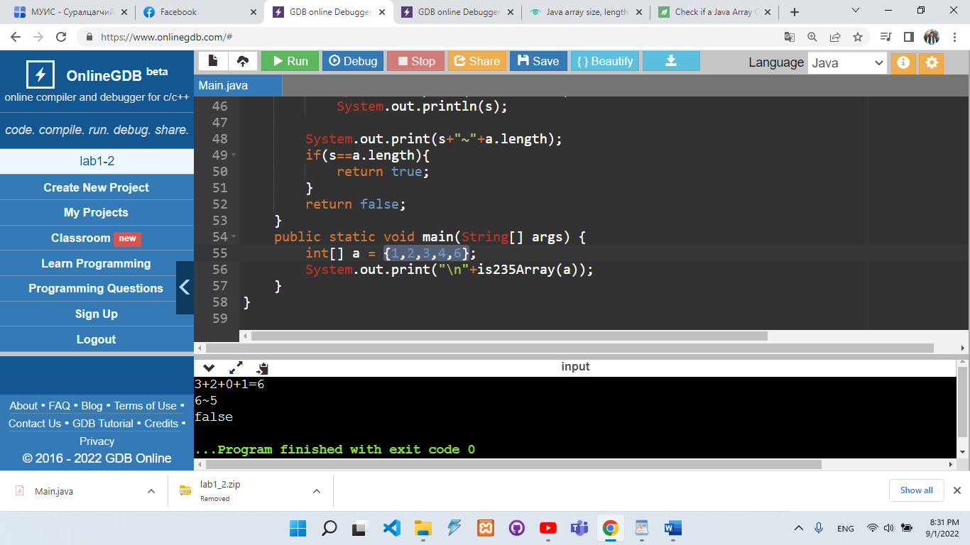

**TRUE**

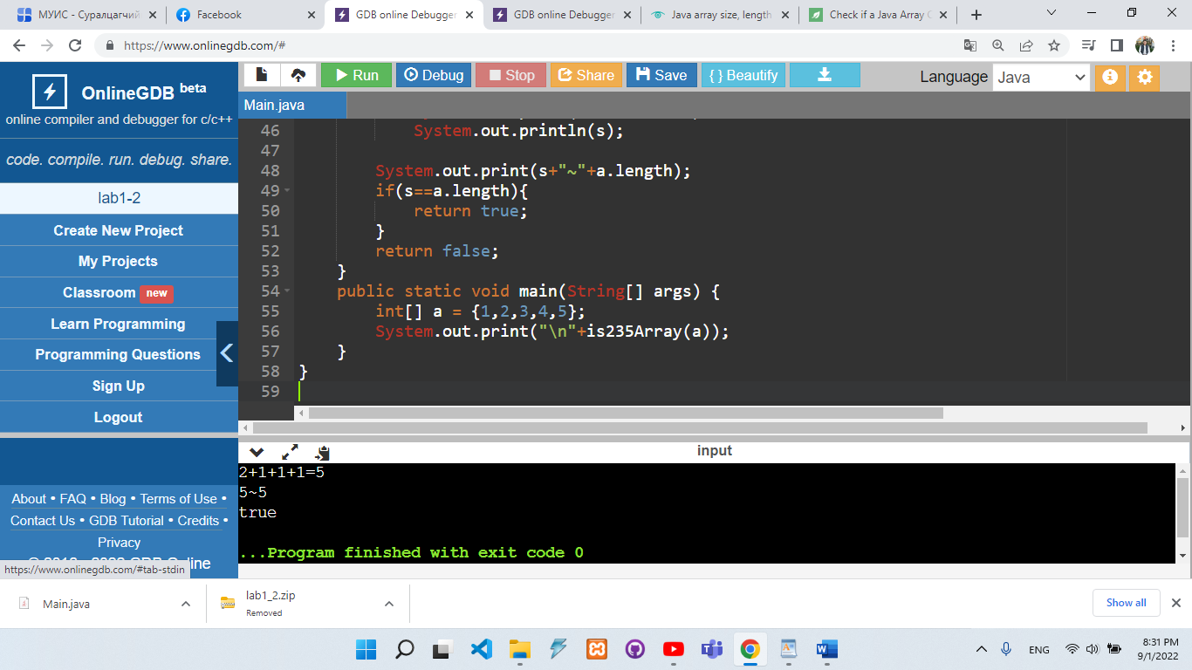

// !!!! Niit 4n davtalt ashglasan ygd 1 davtalt ashglaaguive gevel

//input: {1,2,3,4,5}

//iim massiv bailaa gehed

//2t huvaagddag {0+1+0+1+0} 2

//3t huvaagddag {0+0+1+0+0} 1

//5t huvaagddag {0+0+0+0+1} 1

//235t zereg huvaagdahgui {1+0+0+0+0} 1

//output: 2+1+1+1

//ehleed niit massivaas 2d huvaagdah massiv-g toolno. Duussanii daraa ene shig 3,5d huvaagdah index-uudiig neg burchlen toolno

//4 deh davtalt ni ene 3ni toond zereg huvaagdahgui indexiig

public class Main

{

public static boolean is235Array(int a[]) {

int i,//davtaltiin huvisagch

s = 0,

view = 0;

for(i = 0,view = 0;i<a.length;i++){

if(a[i]%2==0){

s++;

view++;

}

}

System.out.print(view);

for(i = 0,view = 0;i<a.length;i++){

if(a[i]%3==0){

s++;

view++;

}

}

System.out.print("+"+view);

for(i = 0,view = 0;i<a.length;i++){

if(a[i]%5==0){

s++;

view++;

}

}

System.out.print("+"+view);

for(i = 0,view = 0;i<a.length;i++){

if(a[i]%2!=0 && a[i]%3!=0 && a[i]%5!=0){

s++;

view++;

}

}

System.out.print("+"+view+"=");

System.out.println(s);

System.out.print(s+"~"+a.length);

if(s==a.length){

return true;

}

return false;

}

public static void main(String[] args) {

int[] a = {1,2,3,4,5};

System.out.print("\n"+is235Array(a));

}

}